Web Page Sketch:

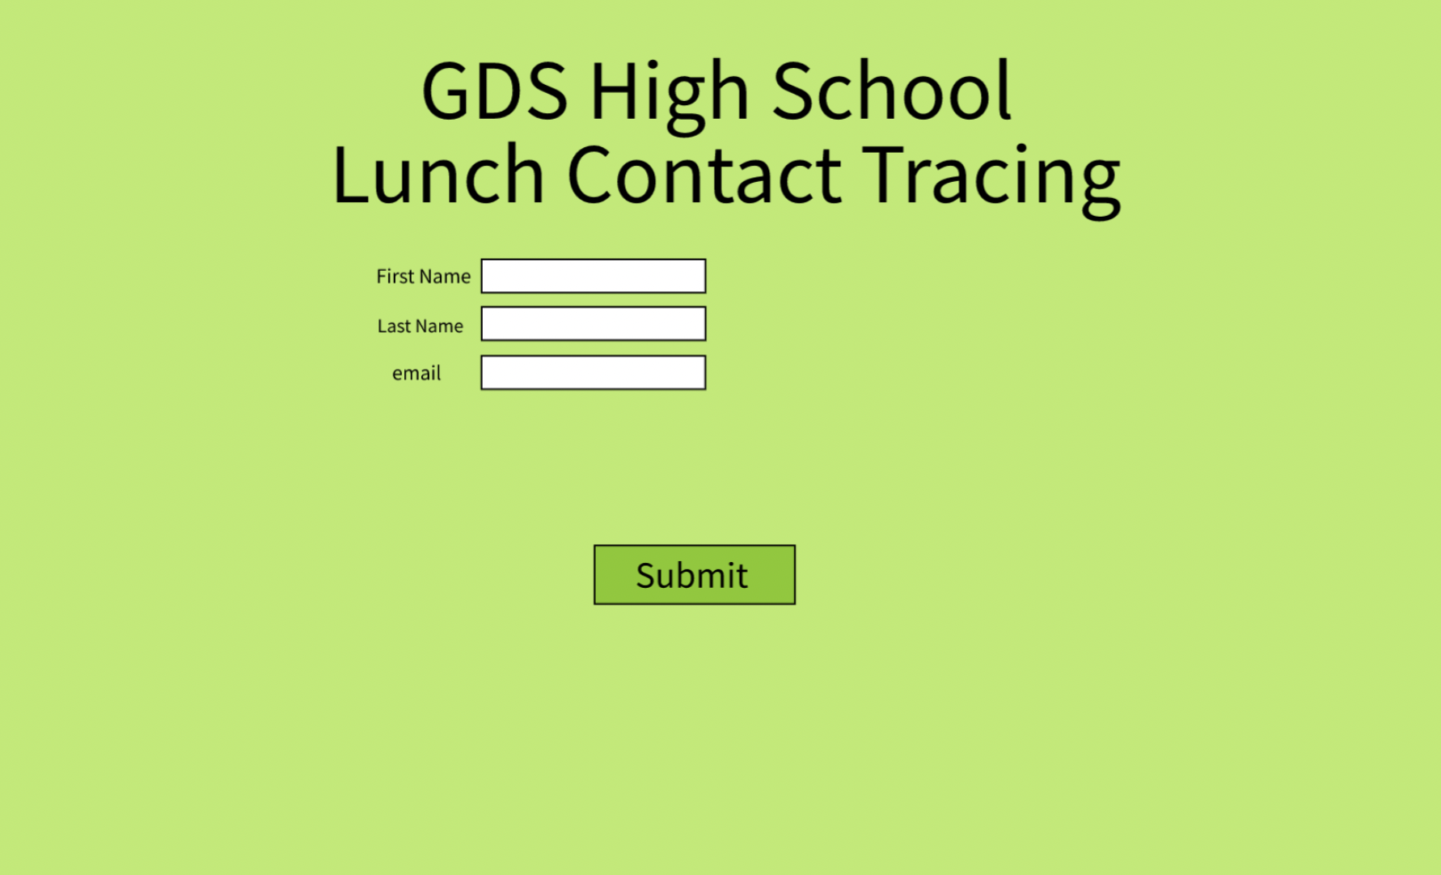

Interactions for user:

* Scan of QR code to identify room
* Input name and email to be recorded by room number and dates